**A Helm chart can be thought of as a Kubernetes package. Charts contain the declarative Kubernetes resource files required to deploy an application.**

**Reference:**

<https://www.youtube.com/watch?v=lLLEmrr9uxQ>

<https://www.golinuxcloud.com/kubernetes-helm-charts/#:~:text=A%20Helm%20chart%20can%20be%20thought%20of%20as,that%20the%20application%20needs%20in%20order%20to%20run>.

**Custom Helm Charts to Deploy Kubernetes Application on AWS EKS:**

* First download helm on your windows machine using the command **“choco install kubernetes-helm”**.
* Created a folder in C- drive with the name “**Custom_Helm_Chart”.**

**Creating Custom Helm Chart**:

* ## Create custom helm

**helm create cqpocshelm**

Once you give this command a folder will be created with the name **cqpocshelm** with allthe necessary filesin **Custom_Helm_chart** Folder.

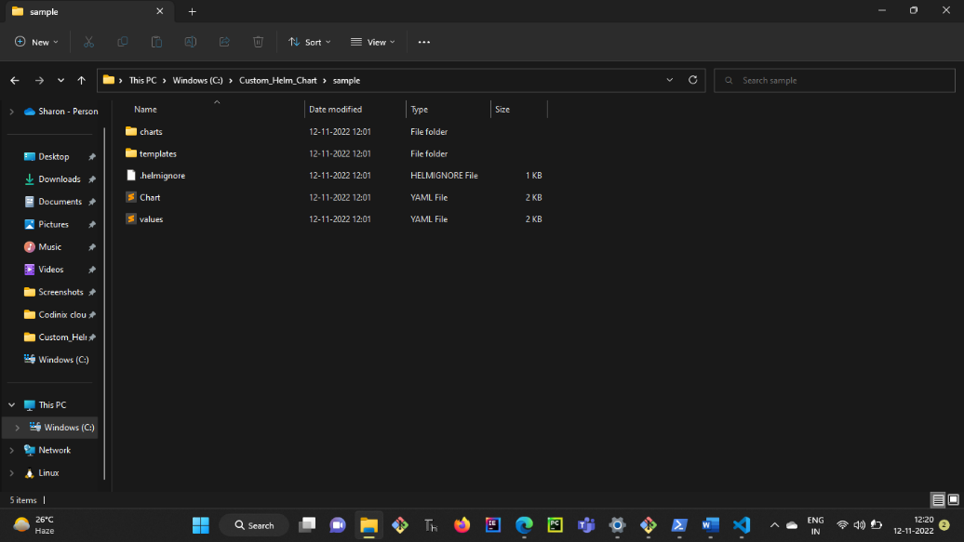

Now replace the existing files in **cqpocshelm** with the files listed in the link below

<https://github.com/sharonraju143/sample_helm.git> and the folder after replacing the files will be shown as below:

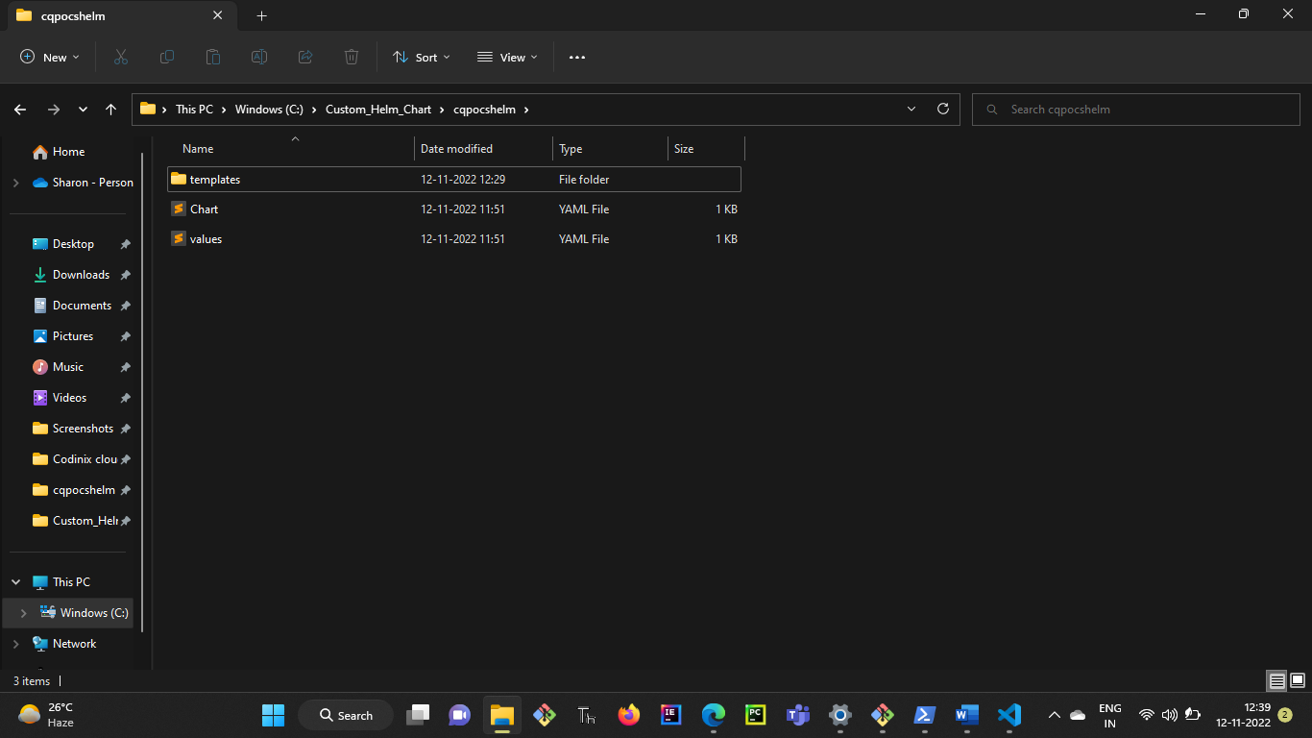

* ## List dependencies

**helm dependency list**

* ## Update dependencies

**helm dependency update**

* ## Vaidate the manifest file

**helm template cqpocshelm\**

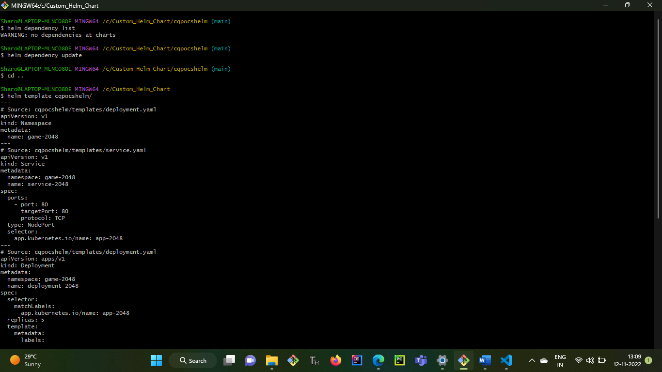

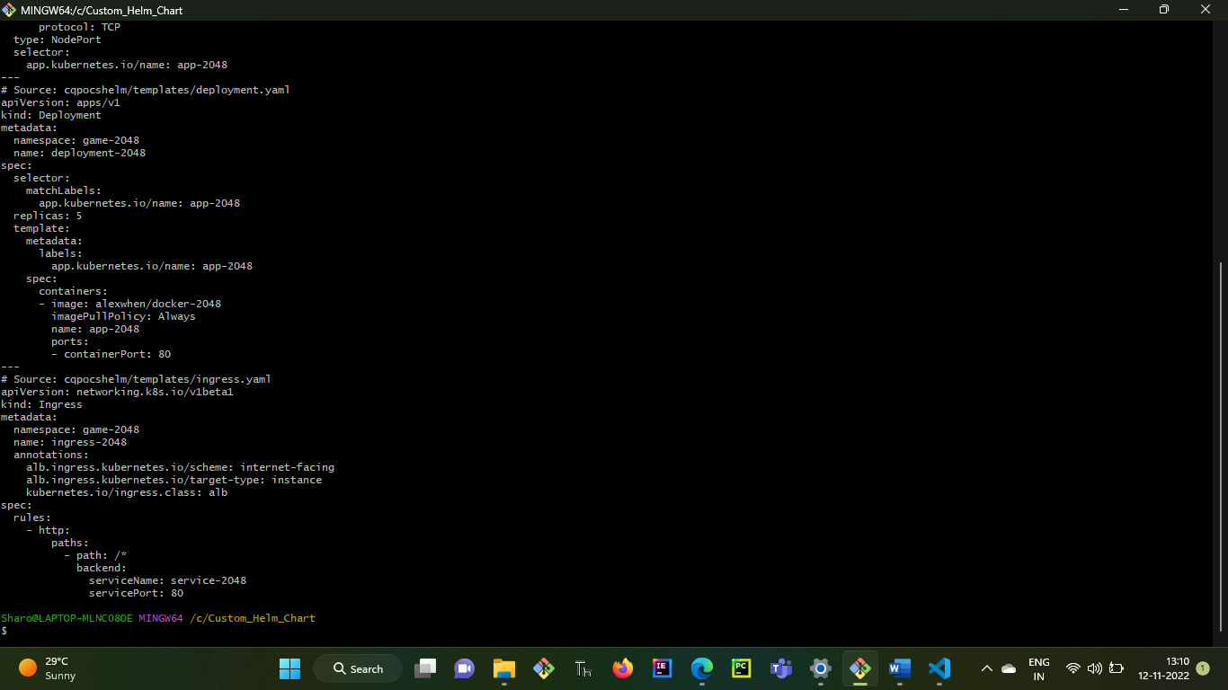

**To install or update eksctl on Windows:**

**“choco install -y eksctl”**

* ## Create EKS cluster

**eksctl create cluster --name cqpocsefkdemo --node-type t2.large --nodes 3 --nodes-min 3 --nodes-max 5 --region us-east-1 --zones us-east-1a,us-east-1b,us-east-1c,us-east-1d,us-east-1f**

* ## Get EKS Cluster service

**eksctl get cluster --name cqpocsefkdemo --region us-east-1**

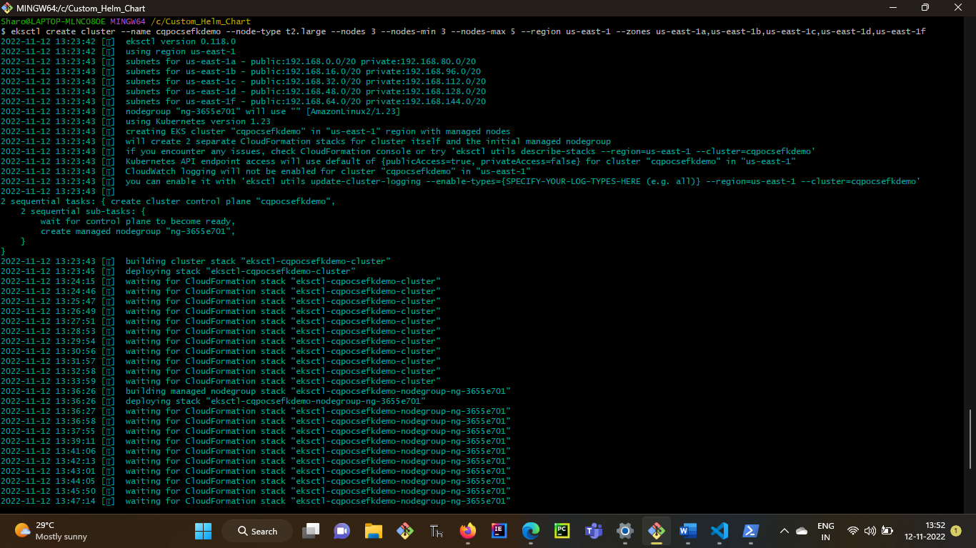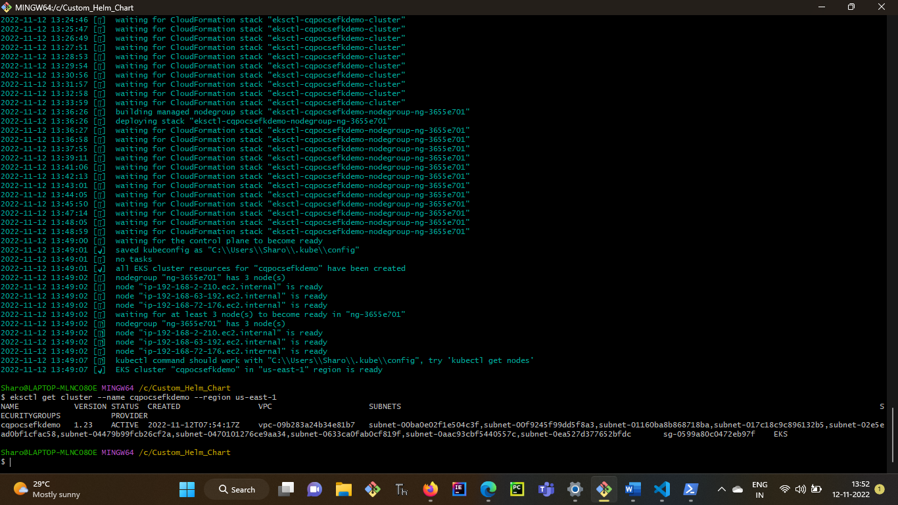

* ## Create IAM OIDC provider

**eksctl utils associate-iam-oidc-provider --region us-east-1 --cluster cqpocsefkdemo –approve**



* ## Create an IAM policy called

**aws iam create-policy --policy-name AWSLoadBalancerControllerIAMPolicy --policy-document file://iam_policy.json**

* ## Create a IAM role and ServiceAccount

**eksctl create iamserviceaccount --cluster cqpocsefkdemo --namespace kube-system --name aws-load-balancer-controller --attach-policy-arn arn:aws:iam::357171621133:policy/AWSLoadBalancerControllerIAMPolicy --override-existing-serviceaccounts --approve**

* ## Install the TargetGroupBinding CRDs

**kubectl apply -k github.com/aws/eks-charts/stable/aws-load-balancer-controller/crds?ref=master**

**kubectl get crd**

* ## Deploy the Helm chart

**helm repo add eks https://aws.github.io/eks-charts**

* ## Configure AWS ALB (Apllication Load Balancer) to sit infront of Ingress

**helm upgrade -i aws-load-balancer-controller eks/aws-load-balancer-controller -n kube-system --set clusterName=cqpocsefkdemo --set serviceAccount.create=false --set serviceAccount.name=aws-load-balancer-controller --set image.tag="v2.2.0"**

* **kubectl -n kube-system rollout status deployment aws-load-balancer-controller**
* ## Install the application

**helm install cqpocs-helm cqpocshelm/**

* ## List kubernetes cluster

**helm ls**

* ## Verify Ingress

**kubectl get ingress/ingress-2048 -n game-2048**

* ## Get Ingress URL

**kubectl get ingress/ingress-2048 -n game-2048 -o jsonpath='{.status.loadBalancer.ingress[0].hostname}'**

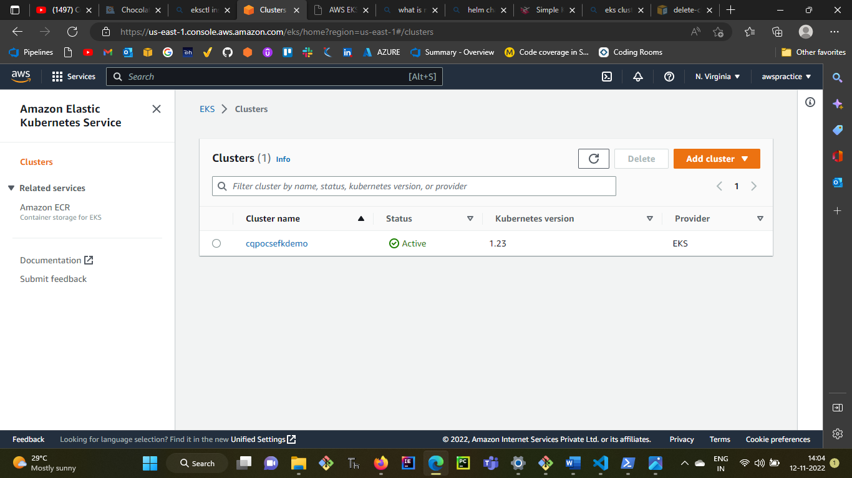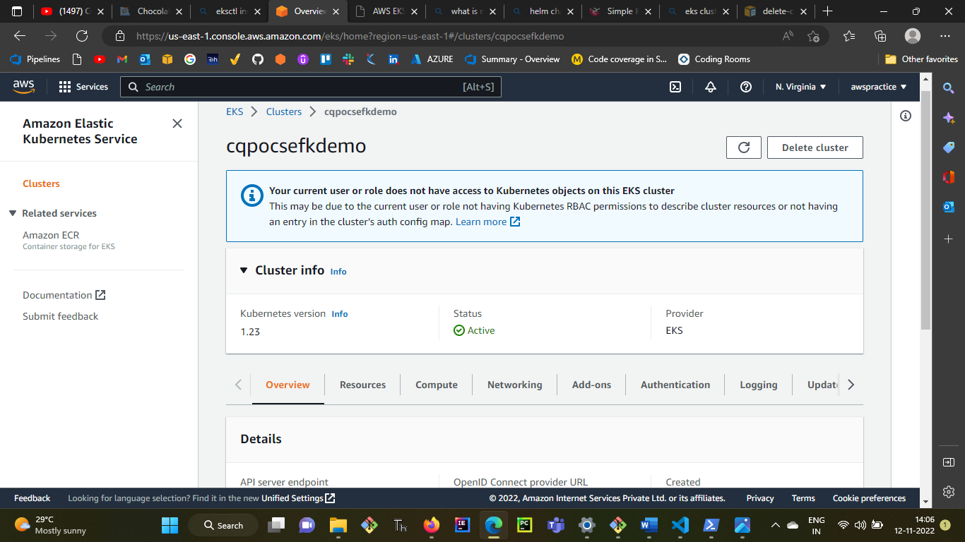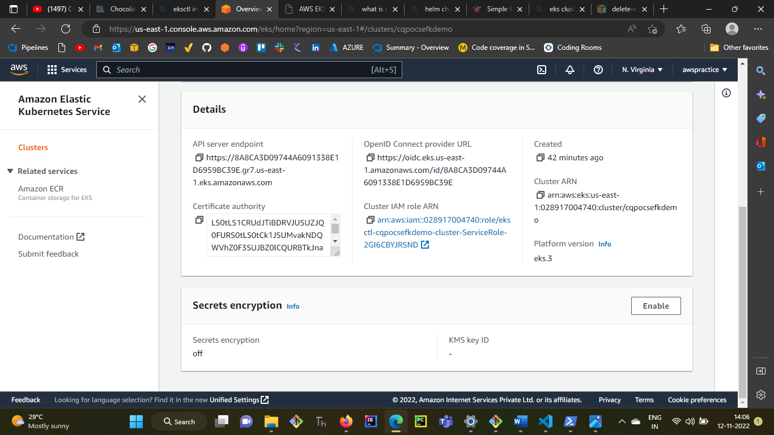

**Chart.yaml**: The Chart.yaml file contains metadata and some functionality controls for the chart.

**charts**: The folder where dependent sub-charts get stored.

**template**s: Templates used to generate Kubernetes manifests are stored in the templates directory.

**NOTES.txt:** This file is a special template. When a chart is installed, the NOTES.txt template is rendered and displayed rather than being installed into a cluster.

**tests:** Templates can include tests that are not installed as part of the install or upgrade commands. This chart includes a test that is used by the helm test command.

**values.yaml**: Default values passed to the templates when Helm is rendering the manifests are in the values.yaml file. When you instantiate a chart, these values can be overridden.